**PRACTICAL – 11**

**AIM: Write a program to perform selective set operation on data stored at 4000H with the data stored at 4001H and store the result at 4002H. Verify the result and write bite wise operation of this program. (OR)**

**CODE:**

ORG 100H

MOV [4000H], 10101011B

MOV [4002H], 11010101B

MOV AL,[4000H]

MOV BL,[4001H]

OR AL,BL

RET

**OUTPUT:**

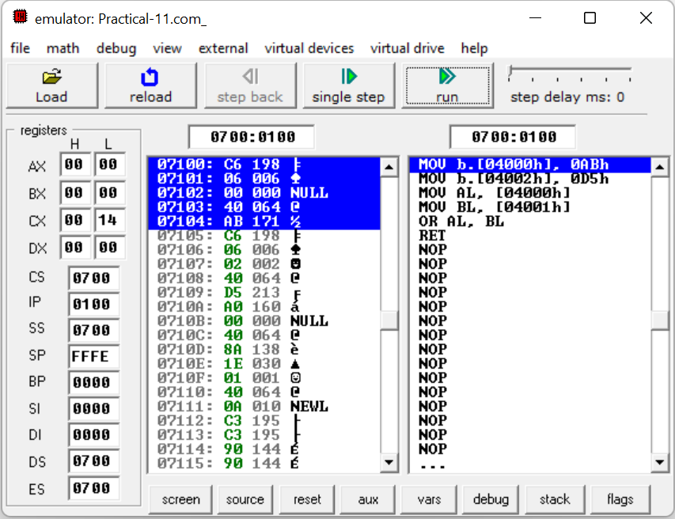

**CONCLUSION:** We learnt how to selective operation on specific location.